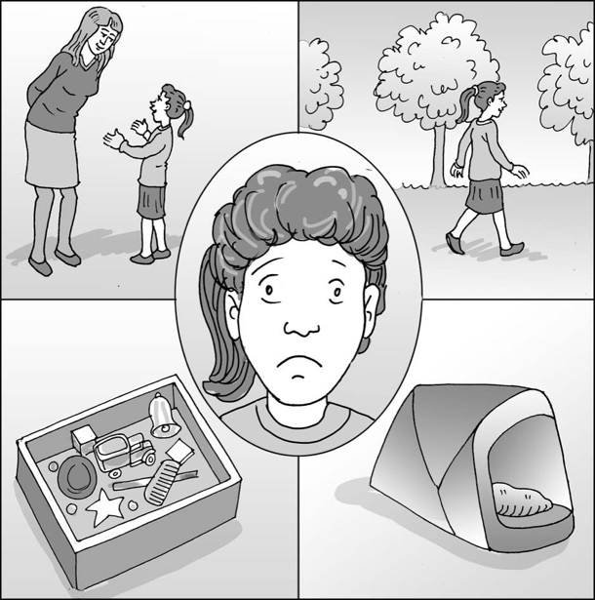
What I can do when I feel upset

My name is .

I am in class.

Every day I do something good. These are the things I like:

My teacher usually tells me I have done something well each day. It is her/his job to teach me new things and notice when I do them well. She/he knows that children make mistakes and this is okay. She/he knows that some things are not easy and take time to get right. This is okay.

Sometimes I feel upset because I don’t understand what to do. Sometimes the instructions are too complicated. Sometimes my classroom is too noisy or bright for me to concentrate. Sometimes I’m having a bad day. This is okay. My teacher understands that I’m not being upset on purpose. There is a reason, and it is okay that I feel upset.

When I feel upset, I can choose one of my calming activities. The choices are on my visual board to remind me. It’s okay if all I want to do is have time out, or I can choose my sensory box/talk with my teaching assistant/walk to .

If I can’t choose, my teacher will help me by showing me to my quiet place/pop up tent/beanbag (etc.) and letting me have some quiet time.

It is good that we have talked about what helps me feel calm after being upset. I can try to tell my teacher what upset me, and she/he will try to make it better. If the work is too hard, she/he can break it into smaller chunks. If someone else did something that upset me, she/he can sort it out. If I’m having a bad day, she/he can put more sensory breaks on my visual timetable.
12

It is okay that school sometimes makes me upset. I can try to remember that I have lots of good times too. It is good that I can have my calming choices when I need them. Then when I feel okay I can carry on and have a good day.

I know what I can do and what help there is when I feel upset.

Well done me!

