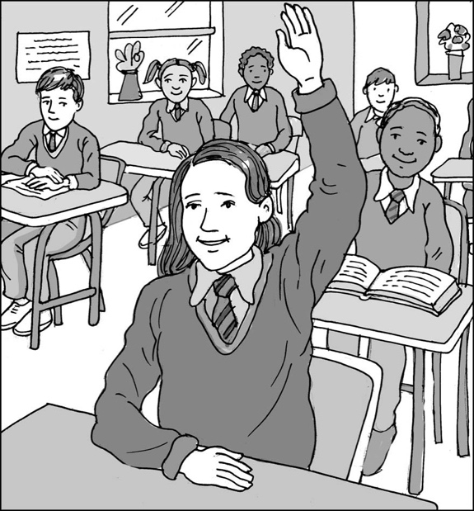
What I can do when I don’t understand

My name is .

I am in class.

We do lots of work at school.

We have different lessons. We do some lessons in the classroom and some lessons in the hall or library, computer room or outside.

Our teachers talk to us to tell us what the lesson is about. They use different ways of giving us information, such as:
- using the whiteboard
- showing us objects
- asking us questions
- reading books to us
- asking us to read things
- getting us to talk to our partners
- getting us to research things, practise things and write about things.

There are a lot of instructions and information to listen to in a school day!

It can be difficult for some children to keep up with all the instructions. The teacher might use words some children don’t understand or use too many words to remember! This is okay.

It is the teacher’s job to help children understand things. If I don’t understand something, there are some things I can do:
- Put my hand up and ask the teacher to explain it again. My teacher will try to use clear words that I can understand. They might show me by doing an example for me or break it into smaller chunks so I can do one part at a time.
- Ask my teaching assistant to explain it again. My teaching assistant will try to use clear words that I can understand. They might show me by doing an example for me or break it into smaller chunks so I can do one part at a time.
39

- They can also write a list for me so I can check it if I forget again. This is a good way to remember things and be able to be in charge of checking it myself.

These things can help me when I don’t understand. No one can understand everything all the time. My teachers know that I try hard and need some help, just like lots of other children do. My teachers will try to help me in a way that makes sense to me. That’s their job and they work hard to help all the children.

This is so we can do the work and learn all the things we need to learn in school.

I can know what to do when I don’t understand.

Well done me!

