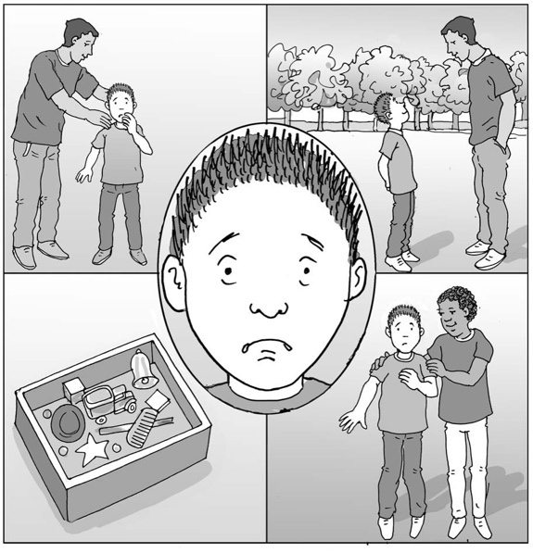
What I can do when I feel scared

My name is .

I am in class.

When I am at home I like .

It can make me feel .
happy safe good okay calm pleased excited

When I am at school, I like .
I feel .

Sometimes people feel scared. These are the things that make me feel scared.

It is okay to feel scared. It is our brain’s way of telling us that there might be danger. When we think there might be danger, our brain tells us to get away from it to keep us safe.

We might be scared because we don’t know what is happening.

We might be scared because there is too much noise, or smells or scary lights and patterns, or not enough sensory information to help us feel safe.
40

It is important to know that there can be things that help me feel safe when I feel scared. These might be:
- asking a trusted adult for help
- getting away to a safe place such as .
- sensory calming activities
- knowing what is going to happen: when, how and why
- thinking about my favourite things
- being brave (once I know what to do) and doing it with help from my friend.

Being scared can cause me to feel overwhelmed and distressed so much that I cannot think clearly and want to get away. My parents and teachers will try to help me by noticing when I feel scared and helping me keep and feel safe.

If I notice that I feel scared, I will try to remember to ask for help or use one of my strategies to get to a safe place. If I can tell my trusted adult why I am feeling scared, they will try to make it better for me.

Being scared is part of everyone’s lives, and some people feel scared a lot of the time. We can learn to feel less scared by finding strategies that help us feel more in control and able to understand what makes us scared. It is okay that being scared is part of me. It is okay and I will be able to learn to be less scared in my own time and with help.

I am precious and unique.

I can try to remember that sometimes I can feel good, happy and okay and enjoy some things like in my list above.

It is okay to be me.

