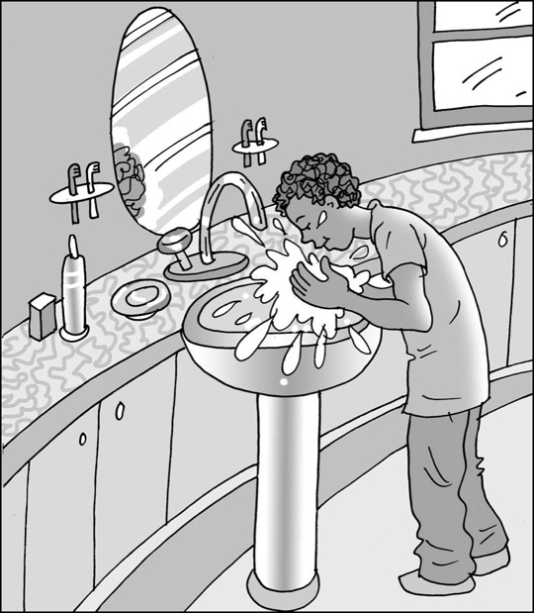
Taking care
of my body

My name is .

I am in class.

It is good to take care of my body. It is good to
clean my body every day. My body is precious.
It is good to look after it.

If people don’t look after their bodies, they can get sore teeth, tangled hair and their skin might feel itchy.

I can try to dress myself. I can try to be clean and stay comfortable in my clothes. Looking in a mirror might help. It might help if I can take some photos of when I am comfortable and clean and put these on my wardrobe.

My parents could help me by putting a weekly timetable on my wardrobe so I know which days to put my clothes in the wash basket. I can choose some more clothes
from my drawers/wardrobe for the next day.

It is good to find things to help me stay clean and healthy that I can manage. There are a lot of different products and my parents might have to help me find ones I can tolerate. This is okay. They understand that my senses are working very hard and sometimes things are just too much.

Every day I can try to brush my teeth. I can try different flavours of toothpaste or
no-flavour toothpaste. I could try listening to a song to help me brush my teeth.
This might be fun.

Every day I can try to brush my hair. I can try a soft brush for my hair.

Every day I can try to wash my hands and face or have a bath or shower. I can work out what is best for me to stay clean. I could try different cloths, sponges and soaps and shampoos that are mild and don’t smell very much.

Every day I can put on comfortable clean clothes and put clothes that I have worn for more than three times in the washing basket.
42

When I do a good job of taking care of my body, I can feel happy, comfortable
and proud.

I can try to do a good job of taking care of my body.

I can be healthy, clean and comfortable!

