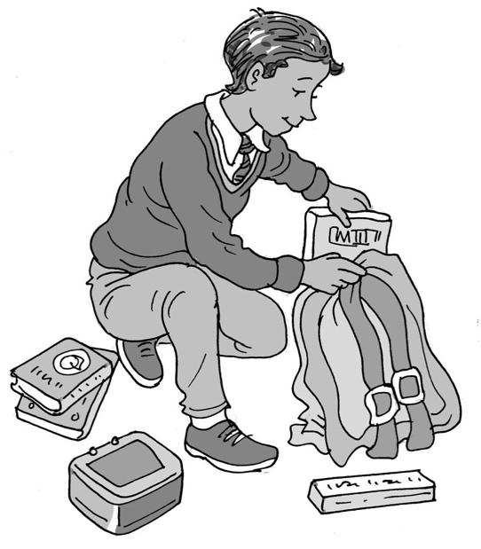
Organising my
bag for school

My name is .

I am in class.

Every day I do different lessons at school. I need the right books and equipment in my bag. I can learn to be really well organised and have everything I need. This is brilliant!

At the end of the day my teacher can give me a list of the things I need for
the next day. I can take the list home and pack my bag with the things I need.

My mum/dad can help me at first and then I can learn to do it myself. I am brilliant!
I could even colour in my timetable the same colour as my books.

This is great because I will have all the things I need at school. This is good because being organised will help me find things easily and be ready for work.

At the end of the next day will swap the list for the
next one.

I can get my bag organised.

Well done me!

56

