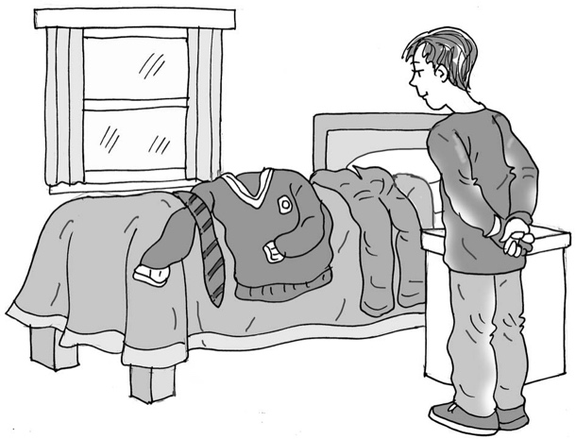
Wearing a
school uniform

My name is .

I am going to School.

Starting school can be exciting and scary for all children.
It is good that I have been to visit my new class and met
my new teacher/teaching assistant. This is good.

When children start school, they are asked to wear a school uniform. A uniform is a set of clothes that look the same. Here is a photo of my friend wearing her/his uniform.

My parents will buy some uniform for me to look at and try before I start school.

My parents know I don’t like new clothes. They will wash them and cut out the labels.

I can touch and get used to the uniform before I start school. This is okay.

When I feel comfortable, I can try the polo shirt/skirt/trousers dress on.
It might help if I look in the mirror and take a photo of me in my uniform.
I can put the picture on my wardrobe.

Well done me. It will be great if I can try to get used to wearing my school uniform, then I will be ready to wear it on my first day at school.

Brilliant.

52

