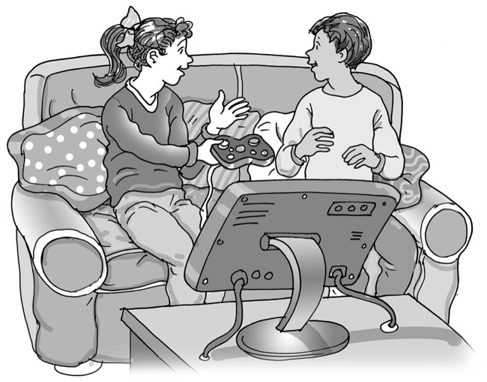
Fighting on the
TV and in video games is not real

My name is .

I am in class.

TV and video game fighting is not real. On TV the people are acting, this means they are pretending. When they fight, it doesn’t really hurt anybody.

TV cartoon and video game fighting is not real. The people are animations or drawings. They are not real and can’t be hurt.

Fighting other children is real. People feel hurt and sore if someone kicks, pushes or punches them.

It is good to touch people gently, keep a space between you and try not to bump into them.

This is being real and respectful to others. They should try to be real and respectful to me too.

This is good.

47

