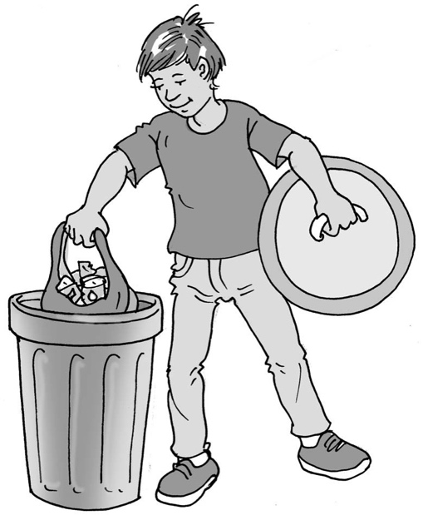
Helping at home

My name is .

I live at home with .

My mum and dad are my parents. Parents have
a great job! Their job is to help their children grow
up healthy and learn all the things they need to do
to look after themselves and others.

The people who live in my house are my family.
When a family lives together, there are things they need to do to help each other.

When the house is untidy or gets dirty, everyone in the family can help make it clean. This is good. My mum and dad might do most of the work but I can help.
What can you do to help make your house clean?*
- Put my dirty clothes in the wash basket.
- Sort the recycling into the right boxes.
- Empty the dishwasher and put the pots in the right cupboards.
- Set the table at tea time.
- Feed the dog/cat/pet.
- Dust the living room/my bedroom.
- Put my toys in their boxes so my parents can hoover the floor.
- Straighten my duvet on my bed after I get up.
(*Choose only one to start with.)

Keeping the house clean is a job that needs to be done every week – when people live in a house together they make things untidy and dirty every day! It is great when everyone helps – that is a great way to be a family.

I can try to do the little jobs my mum and dad show me how to do, and that will be really helpful to all my family. They will help me by taking pictures of what to do and putting the pictures on the fridge/wall/sheet of paper so I can follow them.

My mum and dad know what needs doing and how to help our family work well. This is great. My parents love me very much and want me to learn good things that will help me grow up.
45

I can try to do my jobs and be helpful at home. This is brilliant.

Well done me!

