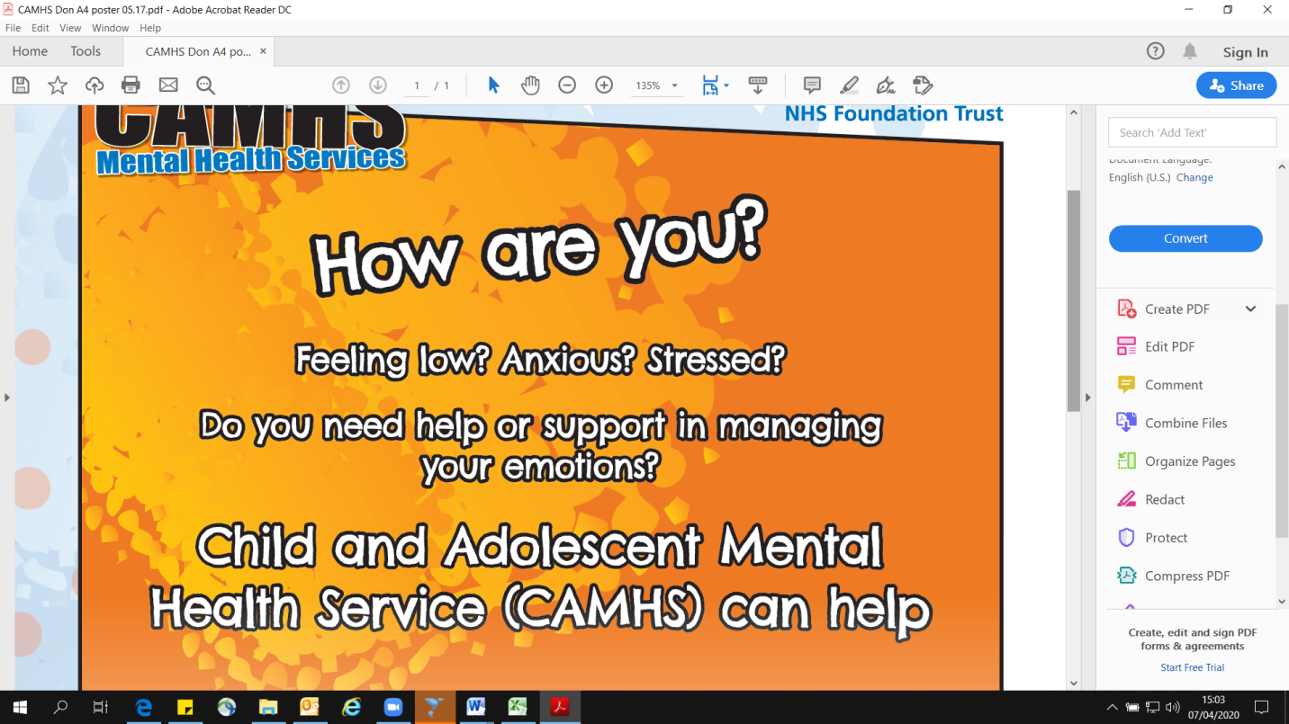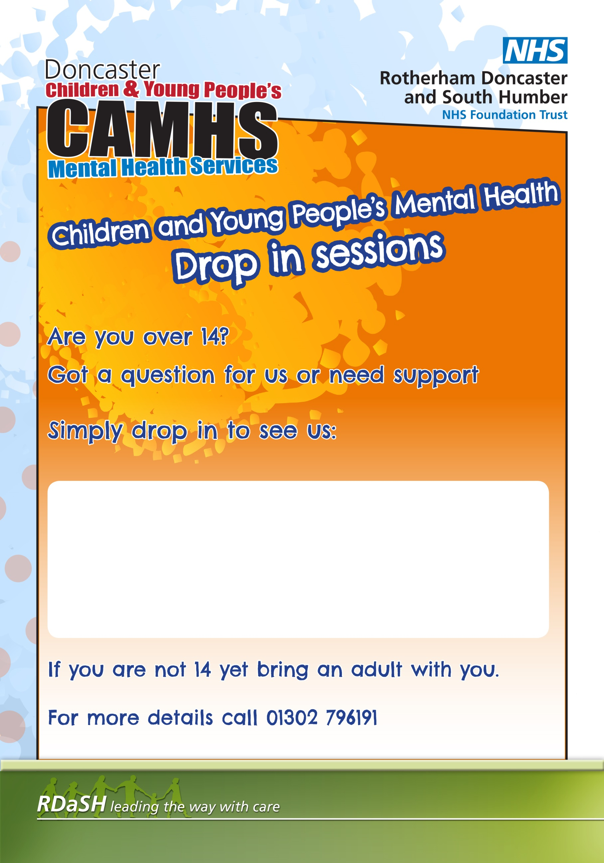

**If you are struggling and need someone to talk to you can call us;**

**Every Tuesday and Thursday 10am-3pm**

**on 01302 796191**

**This service is open to all Doncaster Children and Families.**

**If you are under 14, we would need to speak with an adult too.**