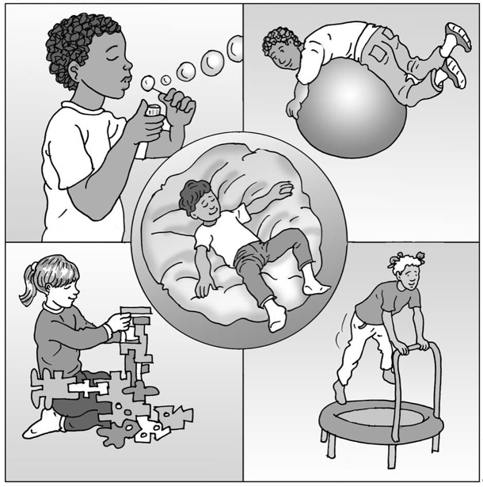
My brain and
my senses

My name is .

I am in class.

My brain works hard.
It makes sense of all the noise, movement, sights, smells, tastes and things I feel all around me.

My brain works hard.
Sometimes there is too much going on in my brain. Too many sensory messages all at once are not good for my brain. This can make me feel anxious/scared/cross/upset/
excited/too full of energy*.

My brain works hard.
Sometimes there is not enough in my brain. Not enough sensory messages make my brain fall asleep. This can make me feel lazy/tired/bothered/distracted/upset*.

My brain works hard.
I can help it be calm, awake and ready to work. This is great.

My brain works hard.
I can do some activities when they are on my visual timetable or when there are too many or not enough messages in my brain.

My brain works hard.
When it is calm and awake, I am ready to listen and work. Hurray!

I like being calm. Awake is good too.
I can try to help myself by using these activities when I feel anxious or can’t do my work. When my brain is too busy or falling asleep, I can help it work better.

My brain works hard. I can help it be the best brain I need.

Well done me!

* Add/delete as appropriate.
13

