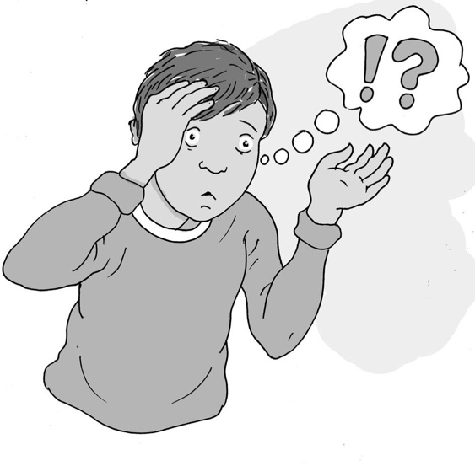
Things sometimes change

My name is .

I am in class

At school my teacher is .
My teaching assistant is .

Usually we have a timetable at school. A timetable is good because the teacher can
get everything ready and the children know what they are going to do.

Usually we have the same teacher and teaching assistant, and they tell us what we are going to do. This is good. I like to know what we are going to do and so do my teachers and the rest of the children in my class.

Sometimes things change. This is okay.

People might feel worried or upset if there is a change. This is usually because they can’t think what the change might be like and don’t know what they will have to do.

Some people don’t like change because it was not what they expected. This is okay.

What kinds of changes happen in your school?
- Supply teacher
- Assembly at different times
- Visitors to school
- Special event

How do you feel when there is a change you weren’t expecting?

It is okay to feel upset or anxious about a change. There are things I can do to help me do the new and unexpected thing.
16

I can ask an adult what is happening and get them to write it down to remind me.

I can ask my teaching assistant to write a plan of where I will be, what I will be doing and when it will finish. Then I can read the plan, take it with me and look at it when I feel worried.

I can use my sensory box or activities to help me feel calm.

I can choose a favourite activity to do with someone and put it on my own visual timetable so I can look forward to this after the change.

I can remember change can be okay, and there are people who will help me.

Well done!

