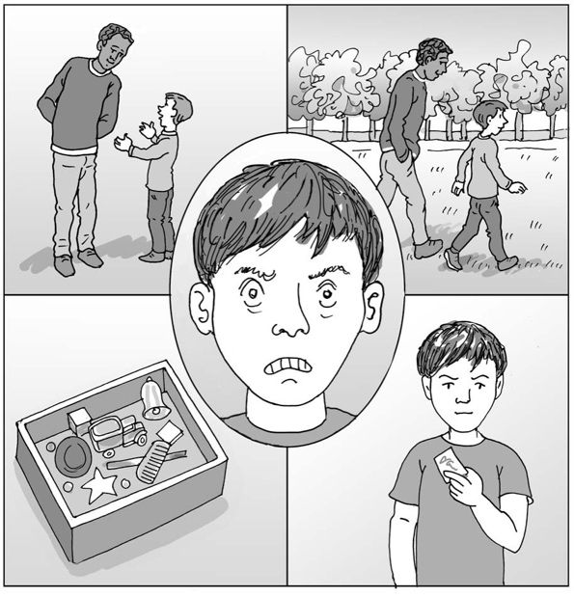
What I can do when I feel angry

My name is .

I am in class.

Being at school all day can be hard work. There are lots of things to remember, things to work out and things to learn.

I am good at lots of things. I like , and
. When I am good at something, it makes me feel good too.
This is great.

Being at school all day means I meet lots of other children and adults. Sometimes I like them and get on well. Sometimes they annoy me and I feel angry.

Anger is a strong feeling that everyone feels sometimes. When we are angry, our brain releases lots of energy into our body. It tells our bodies to fight or run away because it thinks we are in danger. Our brain thinks we are in danger and need to get out of it.

That explains why I sometimes want to hit out at others or run out of my class when
I am angry. I have a lot of energy and want to protect myself.

Being angry is okay, but hitting others and running away isn’t the best thing to do.
It can hurt people and I might be unsafe.

My teachers are helping me work out what things can make me feel angry. Sometimes it is when people are too close to me. Sometimes it is when people say something that
I don’t like. I am learning that I can use my words to ask people to move away or to talk about something else.

My teachers are teaching the other children to do this too. Then we can all learn to be helpful to each other.

20

If I do feel angry:
- I can try to tell my teacher that I am angry.
- I can use my card to ask if I can go to my safe place at .
- My teacher will ask me if I want a sensory activity which I have put in my box because I know it makes me feel better.
- I can ask to go for a walk with Mrs/Mr .

I am learning that being angry is okay and that there are ways we can work together to make angry times better.

Well done me!

