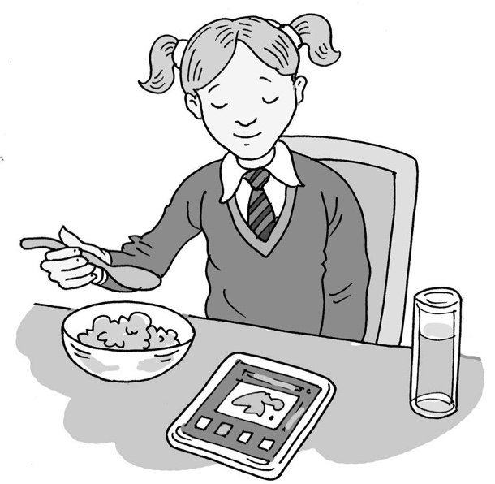
Getting ready
for school

My name is .

I am in class.

Usually on Monday, Tuesday, Wednesday, Thursday and Friday mornings I have to get ready for school.

It can be difficult to wake up and do all the things I need to do before I leave the house with my mum/dad. Getting ready for school is an important part of our routine. School is the place most children go to, and it starts at the same time for everyone. This is so that the register can be taken and no one misses any important information about the day.

My parents and I can make a plan that will help me get ready for school in time. We can make a visual timetable. This might include:
- Get out of bed when my alarm clock makes its noise.
- Go to the toilet and wash my hands and face at the sink.
- Brush my teeth.
- Get dressed.
- Put my shoes on.
- Have breakfast.
- Time to rest and play or have some sensory time.
- My mum’s/dad’s phone will give me a five minute warning so I know I have to finish playing in time to go out of the door to walk to school.

This is a great timetable and will help me remember all that I have to do.

I can try to get up on time and follow my timetable. My parents can help me by coming to check if I am awake when the alarm goes off and pass me my timetable. My parents are happy to make me the breakfast I choose from the list of things we have.

At the weekend (Saturday and Sunday) and in the school holidays, I can choose to get up later because I do not have to go to school. I can still follow my timetable so that I can do things that I like and that my family are doing.
41

Well done me!

