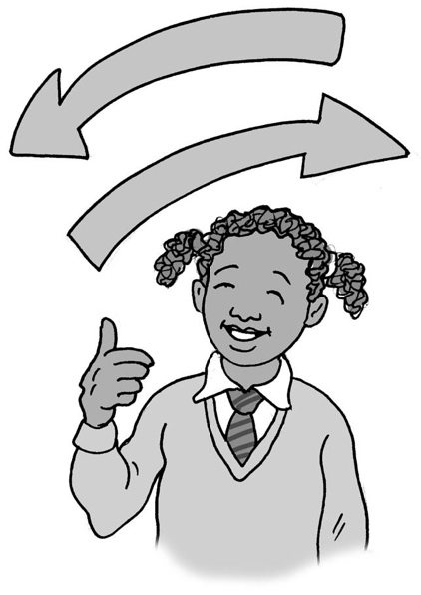
When things change,
I can be okay

My name is .

I am in class.

I live at home with .

I like to know what my day is going to be like. It is important to me to have good routines and be told what I will be doing. My visual timetable helps me know this.

Keeping things the same makes me feel safe. This is good, and my parents and teachers understand this.

Sometimes things change. This can make me feel scared and upset. It takes my brain a long time to understand that something is different and work out what I need to do in the new situation. This is autism. This is okay.

It will be helpful if people at home and school tell me about a change before it happens. I can be helped by:
- being given time to think about the change – don’t rush me
- seeing pictures
- putting the change on my visual timetable
- being able to visit the new place just to look beforehand
- being reminded of what will be the same, and that I can take my comforting toys/activities with me
- being shown how long it will last and what familiar things I can do afterwards
- or .

It is part of life that things do change. It is okay that change makes me feel scared.
I can try to remember that my parents and teachers will help me feel safe. They will make sure I know what I need to be able to cope with the new or unexpected thing.

I can try to remember that some changes are only for a short amount of time, and that some changes can be good. If it is a bad change, then I can try to remember that there are people who will help me. This is good.
48

When things change, I can be okay.

