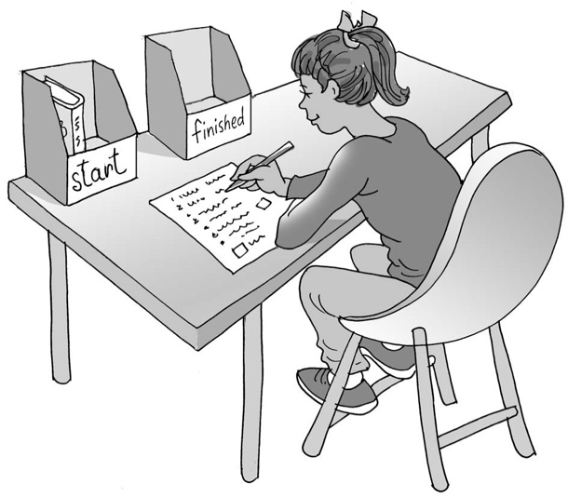
Doing school work at home

My name is .

I am in class.

My teacher gives me homework on a

. All the children in my class get
homework. This is part of school.

Homework helps us remember what we have done in class and lets our teacher know that we can think and write about what we have learned.

At school my teachers help me do my work. At home my parents help me do my homework.

My parents can help me find a quiet and clear space for my homework. I can set up a workstation on the kitchen table or at a desk in my room.

I can remember that it is okay to finish school work at home after 30 minutes’ work. My teacher will be pleased I have tried to work for that time. If I want to work for a bit longer, that is my choice. This is okay.

I can try to remember to put my homework in my bag and give it to my teacher the next day. This is great.

Not many children like doing homework. This is okay. Sometimes we can do something we don’t like so much and still be proud that we got it done.

I can try to get my homework done and then I will have time to do something I like.

I can be proud that I have tried to do some school work at home.

Brilliant!
46

